Nombre ______________ Fecha ______________
Español 1B El Viaje

Parte 1: Look at the photos with options of destinations. Choose your ideal vacation spot and come up with 3 activities that you would like to do during this vacation.

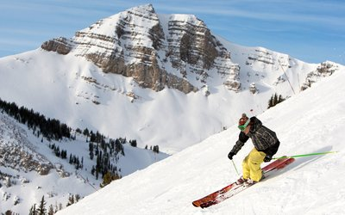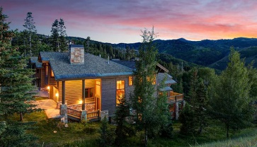

Destino: _______________________________________________________________________________

Actividades:_______________________________________________________________________________________________________________________________________________________________________
El Clima: _______________________________________________________________________________

Diálogo con su amigo

Parte 2: Persuade your friend to take a trip with you to the destination of your choice. Talk about the types of activities you would like to do to encourage your friend to join you. You must each have 5 lines each.

Tú : ________________________________________________________________________________

Tu amigo/a: ________________________________________________________________________

Tú : ________________________________________________________________________________

Tu amigo/a: ________________________________________________________________________

Tú : ________________________________________________________________________________

Tu amigo/a: ________________________________________________________________________
​ Tú : ________________________________________________________________________________

Tu amigo/a: ________________________________________________________________________

Tú : ________________________________________________________________________________

Tu amigo/a: ________________________________________________________________________
Parte 3: Your parents want to know what you decided on. Write them a text about the destination you and your friend decided on. Be sure to include why you chose this destination over others and the activities you would like to do there.

